VACTROL CV CONTROLLER KIT

designed by hzinside

This module is a constant current circuit for driving vactrols to provide cv control over parameters that are controlled by a potentiometer or resistance. It is an add-on board for modifying a module. It features a bias trimmer for the LEDs, to adjust the range of the LED. An additional LED is in the circuit to provide visual feedback of LED inside the vactrol.

There are multiple ways to configure this module. The parts can be mounted directly on the board or attached with wires for panel mounting. Depending on your power source, the electrolytic caps may be omitted. The visual feedback LED can be removed as well. The switch can also be omitted by connecting two of the pads together for an always on setting. Omitting D1 will likely burn out your LEDs, so this part is required.

Power is provided via a 3 pin header on the board for +12V, -12V and GND. Pins may be used or wires may be soldered into the pads depending on your preference. Reverse power protection is included via diodes D2 and D3. If feel that you do not need the protection, these can be replaced with a wire, 10 ohm resistor, or some ferrite beads.

When building this board, install all components except the TL072 opamp. Power the board and measure the voltage on pin #5 (indicated in red in the below image). Adjust the BIAS trimmer (R6) until you read around 0v. The TL072 can then be installed. Once installed, the trimmer can be adjusted to your preference.

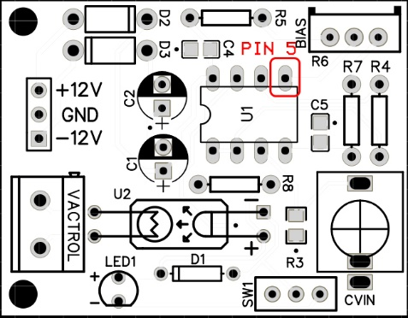

Vactrols may be purchased or can be made yourself with a photoresistor and a LED sealed inside some heat shrink tubing. A photoresistor is also known as a photocell, or light-dependent resistor, LDR, or photo-conductive cell. There are many resources for information regarding building your own vactrols, so I will not include that information here.

If you find this useful, please follow me on Instagram at <https://www.instagram.com/hzinside/>

Copyright (c) 2023 hzinside

The licensor permits others to copy, distribute and transmit the work. In return, licensees may not use the work for commercial purposes such as selling to others. This module is free for non-commercial uses and should not be sold for profit.

THE SOFTWARE IS PROVIDED "AS IS", WITHOUT WARRANTY OF ANY KIND, EXPRESS OR

IMPLIED, INCLUDING BUT NOT LIMITED TO THE WARRANTIES OF MERCHANTABILITY,

FITNESS FOR A PARTICULAR PURPOSE AND NONINFRINGEMENT. IN NO EVENT SHALL THE

AUTHORS OR COPYRIGHT HOLDERS BE LIABLE FOR ANY CLAIM, DAMAGES OR OTHER

LIABILITY, WHETHER IN AN ACTION OF CONTRACT, TORT OR OTHERWISE, ARISING FROM,

OUT OF OR IN CONNECTION WITH THE SOFTWARE OR THE USE OR OTHER DEALINGS IN THE

SOFTWARE.